Multiple Year Stock Data

Results

Tab 2014

Tab 2015

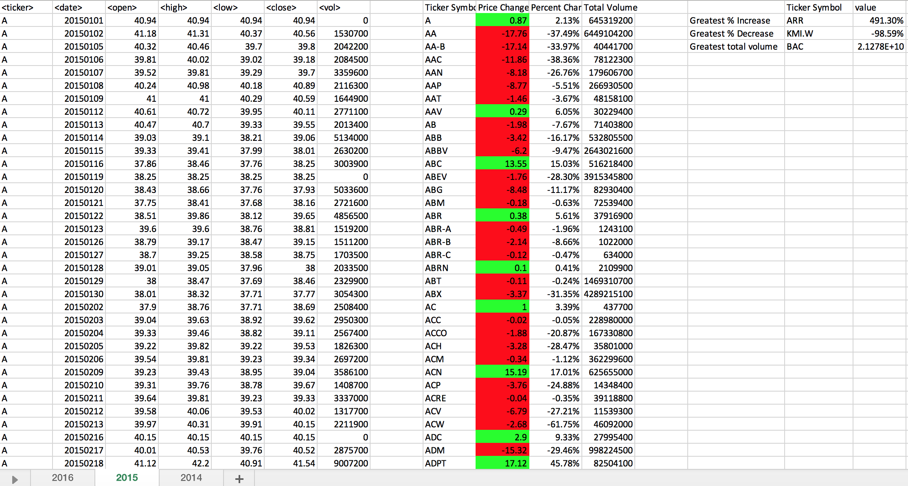

Tab 2016

